**EEE 525 LAB 4**

**Milestone 1**

# Architecture/High-level Block Diagram:

**Module (gcn)**

clk

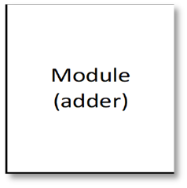

Module

(arg_max)

out_col_ready

Module

(aggregate_fun)

Module

(adder)

element_out

Module

(mult_binary)

dff

dff

dff

dff

dff

dff

dff

dff

dff

dff

dff

dff

dff

dff

dff

dff

dff

row_feature[0]

.

.

row_feature[n]

row_weight[0]

.

.

row_weight[n]

input_addr_fm[0]

input_addr_fm[n]

Input_addr_wm[0]

Input_addr_wm[n] Input_re

COO_mat

out_tranform_col_final

Rst_n

y

we

Output_addr

start

done

***High-level block diagram***

# Design decisions: (with 1-2 appropriate figures)

We have designed the GCN module for a node classification application as follows:

* xxx.
* 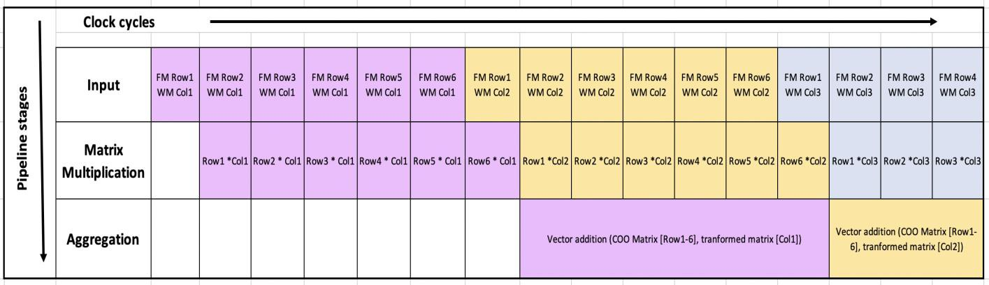xxx:
* *Representation of pipeline stages in design*

## Behavioral Verilog – Simulation:

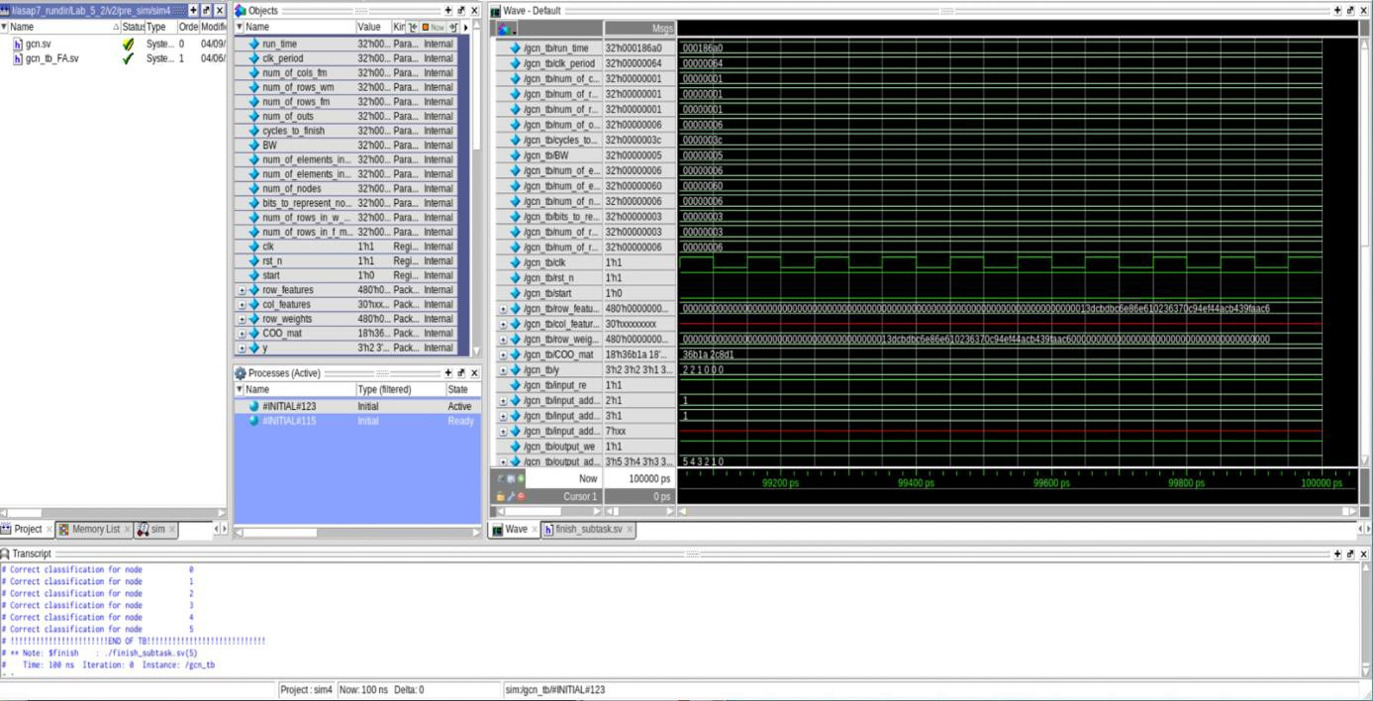

*Correctness of the module with behavioral Verilog*

## Post_Synthesis – Simulation:

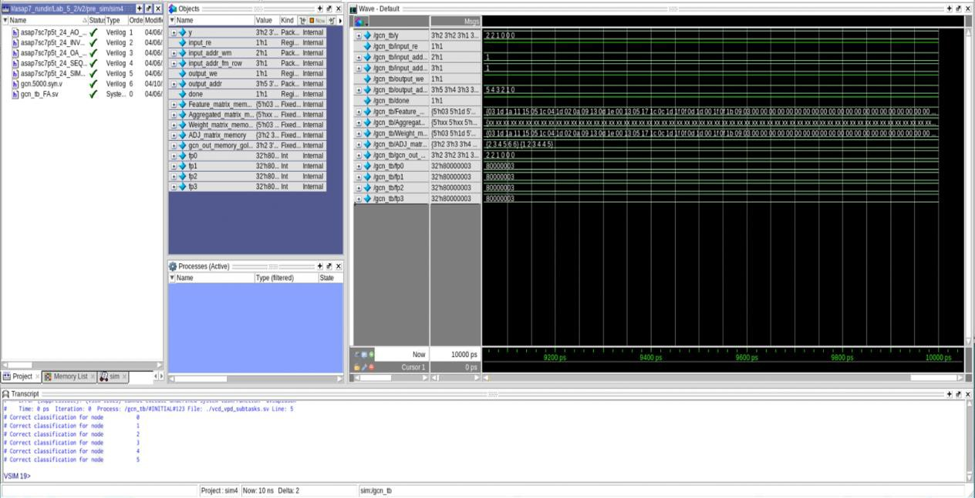

*Correctness of the module with post-synthesis Verilog netlist*

**Milestone 2**

# Total Latency:

* + Total Latency: **xxx ns**, at the clock frequency of **xxx MHz**.
  + Screenshot of Modelsim:

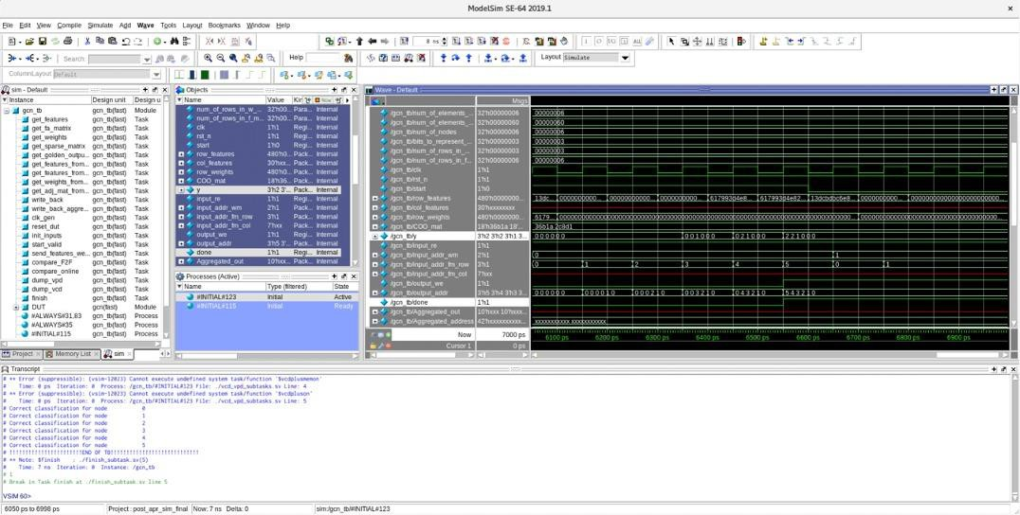

*post APR simulations screenshot*

# Power:

* + Total Power (From Innovus): **xx mW**

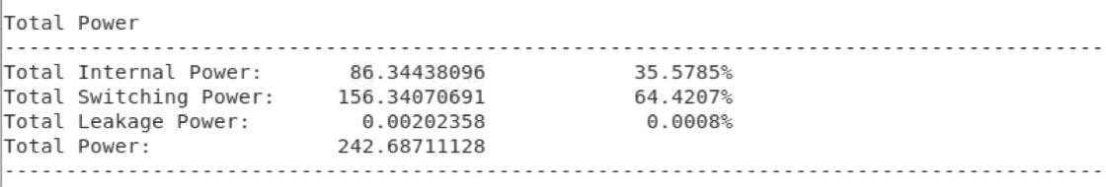

# Area:

* + Standard cells + Filler cells: **xxx mm2**

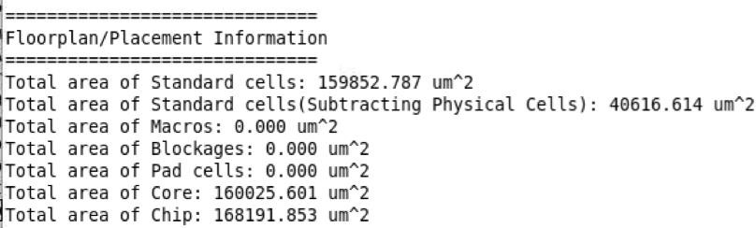

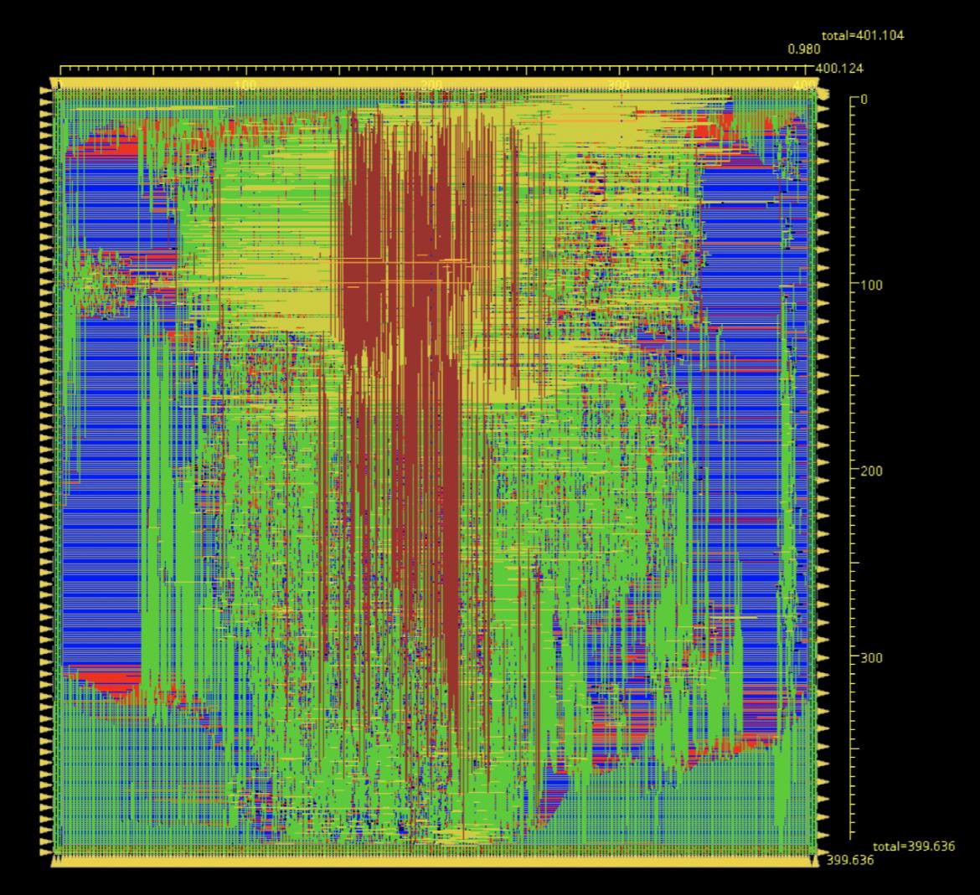*Snippet from log*

*Design x and y dimensions screenshot*

# Innovus density:

* + Before filler cell insertion: **XXX**

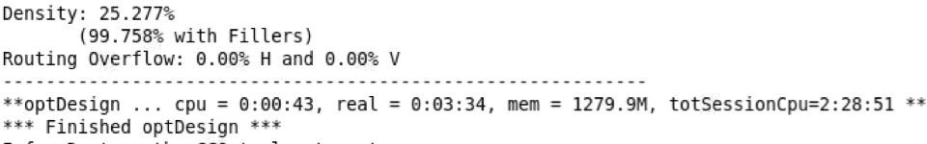

# Number of gates:

* + Gates = **xxx**
  + Cells = **xxx**

## Post_APR – DRC Check:

**Post_APR – LVS Check:**

(Submit your geom.rpt and conn.rpt, as well as attach your screenshot of them here)

**Screenshot of your timing report for the worstcase hold and setup path**

One screenshot of the timing report for the worst setup and worst hold. Do not need the top 3 here.

**Note:**

If you have any additional comments, you can briefly document them here.